Step 0 Intake + Interview Filing Status, Dependency
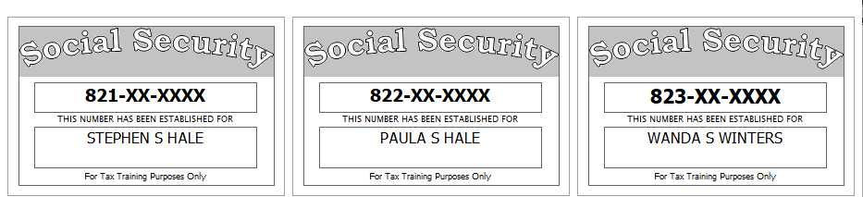

Stephen’s sister, Wanda Winters, is totally and permanently disabled and relies upon her brother for her support. She receives $250 per month in social security benefits. She is covered by Medicare.
Paula has a doctor’s statement that says she has less than 20/200 vision in both eyes (i.e. she is considered blind). However, her blindness does not preclude her from being able to “engage in any substantial gainful activity” (i.e. she is not considered disabled).
Reference: 4012 Tab A, B, C
Tool: IRS Interactive Tax Assistant (link on Preparer page)
Tool: AARP Resource Tool for Counselors (Laminated Flow Chart)
Tool: TP4F Qualifying Child/Qualifying Relative Flowchart Tool (link on Preparer page)
Tool: Dependent Calculator (link on Preparer page)

Step 1 Basic Information
Use the Filing Status from Step 0
Use Intake Sheet and Social Security cards
Extra Interview information for New Jersey:
- All dependents have health insurance (as of the time the return is filed)
- The Hales want their contribution to the Gubernatorial Election Campaign Fund to be handled the same as their contribution to the Presidential Election Campaign Fund.
- Stephen is a veteran, but he does not meet the requirements for the NJ Veteran Exemption
Reference: 4012 Tab B
Tool: NJ Municipality Code Lookup Tool (link on Preparer page)
Tool: NJ 1040 Instructions – Municipality Code Table
Hint: For Profile, use Basic (No Profile)
Hint: Use names from SS Cards (NOT Intake Sheet)
Hint: A simple NJ return will be added after filling in the Federal Personal Information screen. Answer only the subset of the NJ Basic questions asked
Hint: Do not go to the State Section and do anything until you are done with the Federal Section and Health Insurance sections. Use the NJ Checklist to record things you will need to remember when doing the State Section later.
Hint: You do not need to remember or record the NJ PIN
NJ: Fill in Basic Information section of NJ Checklist now
Federal AGI: 0 Federal Refund: 0 NJ Refund: 0

Step 2a Prior Year Return – State Income Taxes paid
Although they received a federal refund on last year’s return, they owed $203 to NJ (which they paid on time). The also owed $42 from their NJ return from three years ago, which they paid on 06-15-2018.
Hint: Search for “STATE” and select “Go to Form Additional Paid State Tax now”
Federal AGI: 0 Federal Refund: 0 NJ Refund: 0
Step 2b Prior Year Return – Capital Loss Carryover
Their prior year return (only available on paper) shows a long-term capital loss carryover of $12,454. The loss belongs to Stephen. There is no short-term capital loss carryover.
Federal AGI: -3,000 Federal Refund: 0 NJ Refund: 0
Step 3 1099-R
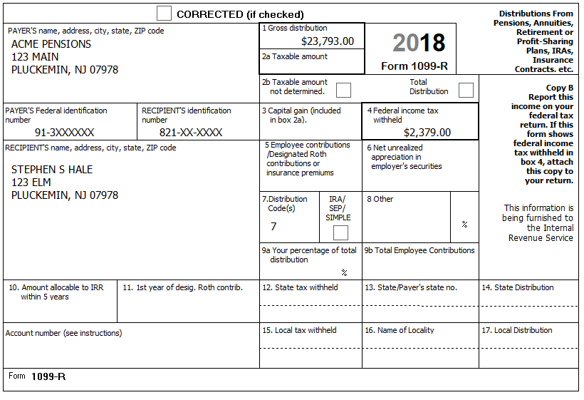
Federal AGI: 20,793 Federal Refund: 2,379 NJ Refund: 0
Step 4 CSA 1099-R
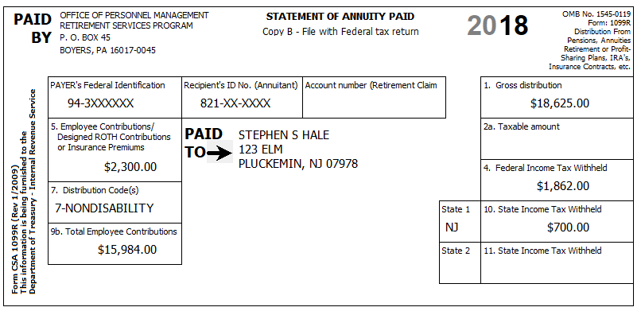
Stephen started receiving this pension on February 1, 2011. Paula is also covered by the plan.
They confirm that the amount in Box 5 is for medical insurance.
Tool: Annuity Calculator (link on Preparer page)
Hint: Use the Annuity Calculator to figure out the entries for the TSO Simplified Method worksheet
NJ: Add untaxed portion (Box 1 – Box 2a) to NJ Checklist (Adjustments to Line 20b)
Step 4a Form 1099-R
Federal AGI: 38,799 Federal Refund: 3,523 NJ Refund: 700
Step 4b Schedule A – Medical Deductions
BP: Enter the insurance costs on Sch A now (to avoid forgetting to do so later)
Federal AGI: 38,799 Federal Refund: 3,523 NJ Refund: 700
Q: Why did NJ Refund go up?
Step 5 1099-R
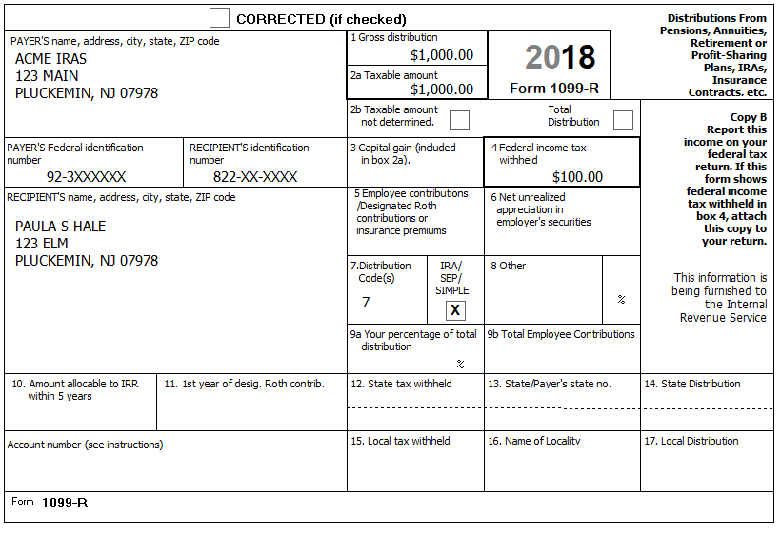
Federal AGI: 39,799 Federal Refund: 3,523 NJ Refund: 700
Q: Paula took this distribution in November – If she had taken it in June, then a) would the 1099-R be different? and b) would the federal and/or NJ refund change?
Q: Why didn’t the Federal Refund change from the previous step?
Step 6 SSA-1099 – Stephen
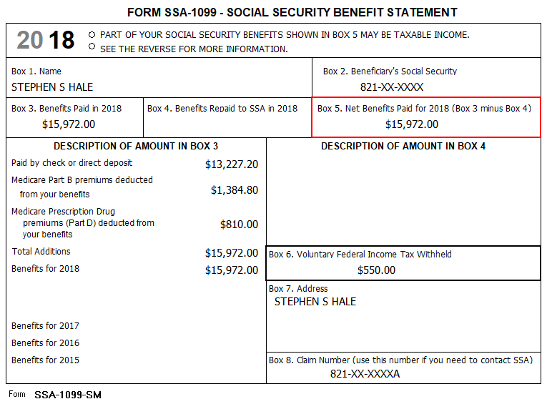
Federal AGI: 49,016 Federal Refund: 3,081 NJ Refund: 700
Q: Social Security is not taxable in NJ - Why did the NJ Refund change?
Step 7 K-1
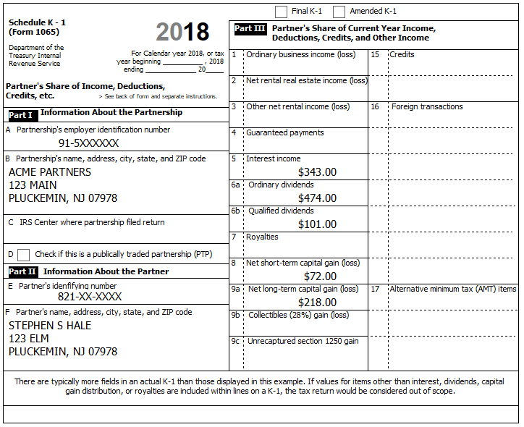
In addition to the above, Box 18a shows $31.00 of Tax Exempt Interest Income. This amount is all from Tax-exempt Federal obligations
You determine that a) This is a Passive Entity, b) All Investment is At-Risk, c) The entire investment has not been disposed, d) This is not a PTP, and e) there is no Prior Year Unallowed Loss
NOTE: As of 01-04-2019 there is a bug in TSO where it is not including amounts from K-1 box 5 (Interest Income) in NJ-1040, line 16a (Taxable Interest). Workaround: Do not enter box 5 amount on K-1 screen; enter box 5 amount as separate 1099-INT.
Reference: 4012 D-47 to D-49
Federal AGI: 50,554 Federal Refund: 2,907 NJ Refund: 700
Check: Fed 1040, line 2a=31; 2b=343; 3a=101; 3b=474
Check: NJ-1040, line 16a=343; 16b=31; 17=474

Step 8 Brokerage Statement Page 1 of 4 – 1099-INT
Acme Brokerage | End of Year Tax Information Statement  Tax Year 2018 • Account 203040506 | Statement Date: 01-30-2019  Page 1 of 4 | 2018
123 Main  P.O. Box 07978-123  Pluckemin, NJ 07978  PAYER’S Federal ID No: 92-2XXXXXX | Stephen S. Hale  123 Elm  Pluckemin, NJ 07978  RECIPIENT’S ID No: 821-XX-XXXX | Your Broker:  SERGE BRONSKI  888-555-5555  sbronski@acme.com

Interest Income – 1099-INT – Reported to IRS
1 | Interest Income (not included in line 3) | 124.73
2 | Early withdrawal penalty | 0.00
3 | Interest on US Savings Bonds & Treasury obligations | 506.00
4 | Federal Income tax withheld | 50.00
5 | Investment expenses | 0.00
6 | Foreign tax paid | 0.00
7 | Foreign country or US possession
8 | Tax-exempt interest (includes line 9) | 337.86
9 | Specified private activity bond interest (AMT) | 4.00
10 | Market discount
11 | Bond premium
12 | Bond premium on Treasury obligations
13 | Bond premium on tax-exempt bond
14 | Tax-exempt bond CUSIP numbers (see instructions)
15 | State
16 | State ID numbers
17 | State tax withheld | 0.00
 | FATCA filing requirement | NO

Interest Detail (only summary 1099-INT reported to IRS)
Date | 1 Interest Income | 2 Early withdrawal penalty | 3 Interest on US Savings Bonds | 4 Federal withholding | 8 Tax-exempt interest
Safe Stuff
12-30-2018 | 124.73 | 0.00 | 506.00 | 50.00 | 0.00
New Jersey Muni Bond
12-30-2018 | 0.00 | 0.00 | 0.00 | 0.00 | 148.64
New York Muni Bond
12-30-2018 | 0.00 | 0.00 | 0.00 | 0.00 | 189.22
Totals: | 124.73 | 0.00 | 506.00 | 50.00 | 337.86

The Savings Bond interest was not used for any tax-exempt purpose.

Step 8a Interest Income Screen
Federal AGI: 52,009 Federal Refund: 2,783 NJ Refund: 700
Check: Fed 1040, line 2a=369; 2b=974; 3a=101; 3b=474
Check: NJ-1040, line 16a=468; 16b=875; 17=474
Step 8b Taxable State Interest Item Screen
Federal AGI: 52,009 Federal Refund: 2,783 NJ Refund: 700
Check: Fed 1040, line 2a=369; 2b=974; 3a=101; 3b=474
Check: NJ-1040, line 16a=657; 16b=686; 17=474

Step 9 Brokerage Statement Page 2 of 4 – 1099-DIV
Acme Brokerage | End of Year Tax Information Statement  Tax Year 2018 • Account 203040506 | Statement Date: 01-30-2019  Page 2 of 4 | 2018
123 Main  P.O. Box 07978-123  Pluckemin, NJ 07978  PAYER’S Federal ID No: 92-2XXXXXX | Stephen S. Hale  123 Elm  Pluckemin, NJ 07978  RECIPIENT’S ID No: 821-XX-XXXX | Your Broker:  SERGE BRONSKI  888-555-5555  sbronski@acme.com

Dividends and Distributions – 1099-DIV – Reported to IRS
1a | Total ordinary dividends (includes line 1b) | 231.86
1b | Qualified dividends | 125.25
2a | Total capital gain distributions (includes lines 2b, 2c, 2d) | 68.75
2b | Unrecaptured Section 1250 gain | 0.00
2c | Section 1202 gain | 0.00
2d | Collectibles (28%) gain | 0.00
3 | Nondividend distributions | 32.44
4 | Federal Income tax withheld | 80.00
5 | Section 199A dividends | 0.00
6 | Investment expenses | 0.00
7 | Foreign tax paid | 43.75
8 | Foreign country or US possession
9 | Cash liquidation distributions | 0.00
10 | Noncash liquidation distributions | 0.00
11 | Exempt-interest dividends (includes line 12) | 400.00
12 | Specified private activity bond interest dividends (AMT) | 22.00
13 | State
14 | State ID number
15 | State tax withheld | 0.00
 | FATCA filing requirement | NO

Dividend Detail (only summary 1099-DIV reported to IRS)
Date | 1a Ordinary dividends | 1b Qualified dividends | 2a Capital gains | 3 Nondiv. Dists. | 4 Federal w/h | 6 Foreign tax paid | 10 Exempt Interest | 11 Sp. PAB
Boring Mutual Fund (BMF)
12-30-2018 | 231.86 | 125.25 | 68.75 | 32.44 | 80.00 | 43.75 | 0.00 | 0.00
Select US Tax-Exempt Fund (SUSTE)
12-30-2018 | 0.00 | 0.00 | 0.00 | 0.00 | 0.00 | 0.00 | 200.00 | 0.00
Select NJ Qualified Fund (SNJQTE)
12-30-2018 | 0.00 | 0.00 | 0.00 | 0.00 | 0.00 | 0.00 | 200.00 | 22.00
Totals: | 231.86 | 125.25 | 68.75 | 32.44 | 80.00 | 43.75 | 400.00 | 22.00

Exempt-Interest Dividends by Area
Area | SUSTE | SNJQTE
Alabama | 1.3% | -
Alaska … Nevada | 28.2% | -
New Hampshire | 0.5% | -
New Jersey | 10.0% | 70.0%
New Mexico | 0.7% | -
New York … Wisconsin | 29.1% | 7.0%
Wyoming | 0.2% | -
District of Columbia | 0.2% | 1.0%
Puerto Rico | 9.7% | 2.0%
US Possessions | 20.1% | 20.0%
Total | 100.0% | 100.0%
Step 9a Dividend Income Screen
Federal AGI: 52,778 Federal Refund: 2,829 NJ Refund: 700
Check: Fed 1040, line 2a=769; 2b=974; 3a=226; 3b=706
Check: NJ-1040, line 16a=657; 16b=1086; 17=706
Step 9b Taxable State Interest Item Screen
Federal AGI: 52,778 Federal Refund: 2,829 NJ Refund: 700
Check: Fed 1040, line 2a=769; 2b=974; 3a=226; 3b=706
Check: NJ-1040, line 16a=811; 16b=932; 16=706

Step 10 Brokerage Statement Page 3 of 4 – 1099-B
Acme Brokerage | End of Year Tax Information Statement  Tax Year 2018 • Account 203040506 | Statement Date: 01-30-2019  Page 3 of 4 | 2018
123 Main  P.O. Box 07978-123  Pluckemin, NJ 07978  PAYER’S Federal ID No: 92-2XXXXXX | Stephen S. Hale  123 Elm  Pluckemin, NJ 07978  RECIPIENT’S ID No: 821-XX-XXXX | Your Broker:  SERGE BRONSKI  888-555-5555  sbronski@acme.com

FORM 1099-B 2018 Proceeds from Broker and Barter Exchange Transactions
Long-term transactions for which basis is not reported to the IRS - Report on form 8949 with Box E checked
1a Description, 2 Long-term, 3 Basis not reported to IRS, 6 Net Proceeds
Quantity | 1b Date Acquired | 1c Date Sold | 1d Proceeds | 1e Cost or other Basis | 1f Code | 1g Adj | Gain / Loss(-) | 4 Federal Tax Withheld
Acme Corp (ZACO)
50.000 | 09-01-1996 | 05-10-2018 | 3,462.00 | 3.181.00 |  |  | 281.00 | 0.00
100.000 | 09-01-1996 | 10-20-2018 | 7,226.00 | 6,362.00 |  |  | 864.00 | 0.00
150.000 |  |  | 10,688.00 | 9,543.00 |  | 0.00 | 1,145.00 | 0.00
Acme Inc (ZAI)
65.000 | ** | 10-20-2018 | 5.663.00 | ** | W | 97.00 | ** | 0.00
Totals |  |  | 16,351.00 |  |  |  |  | 0.00
** Information not available

Acme Brokerage does not have a record for the purchase of ZAI stock. Stephen inherited the 65 shares from his uncle who paid $6,500 for the shares on 10/15/2008. The stock was worth $7,222 on 08/29/2018, the day his uncle died.
Federal AGI: 52,778 Federal Refund: 2,829 NJ Refund: 700
Q: Why did the Federal AGI and Refund not change?

Step 11 Brokerage Statement Page 4 of 4 – 1099-B
Acme Brokerage | End of Year Tax Information Statement  Tax Year 2018 • Account 203040506 | Statement Date: 01-30-2019  Page 4 of 4 | 2018
123 Main  P.O. Box 07978-123  Pluckemin, NJ 07978  PAYER’S Federal ID No: 92-2XXXXXX | Stephen S. Hale  123 Elm  Pluckemin, NJ 07978  RECIPIENT’S ID No: 821-XX-XXXX | Your Broker:  SERGE BRONSKI  888-555-5555  sbronski@acme.com

FORM 1099-B 2018 Proceeds from Broker and Barter Exchange Transactions
Long-term transactions for which basis is reported to the IRS - Report on form 8949 with Box D checked
1a Description, 2 Long-term, 3 Basis reported to IRS, 6 Net Proceeds
Quantity | 1b Date Acquired | 1c Date Sold | 1d Proceeds | 1e Cost or other Basis | 1f Code | 1g Adj | Gain / Loss(-) | 4 Federal Tax Withheld
Acme Corp (ZACO)
10.000 | 07-02-2002 | 01-15-2018 | 350.00 | 340.00 |  |  | 10.00 | 0.00
10.000 | 07-02-2002 | 02-15-2018 | 340.00 | 340.00 |  |  | 0.00 | 0.00
10.000 | 07-02-2003 | 03-15-2018 | 350.00 | 320.00 |  |  | 30.00 | 0.00
10.000 | 07-02-2003 | 04-15-2018 | 340.00 | 320.00 |  |  | 20.00 | 0.00
10.000 | 07-02-2003 | 05-15-2018 | 350.00 | 320.00 |  |  | 30.00 | 0.00
10.000 | 07-02-2003 | 06-15-2018 | 340.00 | 320.00 |  |  | 20.00 | 0.00
10.000 | 07-02-2003 | 07-15-2018 | 350.00 | 320.00 |  |  | 30.00 | 0.00
10.000 | 07-02-2003 | 08-15-2018 | 340.00 | 320.00 |  |  | 20.00 | 0.00
10.000 | 07-02-2003 | 09-15-2018 | 350.00 | 320.00 |  |  | 30.00 | 0.00
10.000 | 07-02-2003 | 10-15-2018 | 340.00 | 320.00 |  |  | 20.00 | 0.00
10.000 | 07-02-2003 | 11-15-2018 | 350.00 | 320.00 |  |  | 30.00 | 0.00
10.000 | 07-02-2003 | 12-15-2018 | 340.00 | 320.00 |  |  | 20.00 | 0.00
120.000 |  |  | 4,140.00 | 3,880.00 |  | 0.00 | 260.00 | 0.00
Acme Inc (ZAI)
30.000 | 07-02-2007 | 03-15-2018 | 330.00 | 300.00 |  |  | 30.00 | 0.00
30.000 | 07-02-2007 | 06-15-2018 | 330.00 | 300.00 |  |  | 30.00 | 0.00
30.000 | 07-02-2008 | 09-15-2018 | 330.00 | 340.00 |  |  | -10.00 | 0.00
30.000 | 07-02-2008 | 12-15-2018 | 330.00 | 340.00 |  |  | -10.00 | 0.00
120.000 |  |  | 1.320.00 | 1,280.00 |  | 0.00 | 40.00 | 0.00
Acme Ltd (ZALTD)
30.000 | 07-02-2007 | 03-15-2018 | 3,210.00 | 700.00 |  |  | 2,510.00 | 0.00
30.000 | 07-02-2007 | 06-15-2018 | 3,220.00 | 700.00 |  |  | 2,520.00 | 0.00
30.000 | 07-02-2008 | 09-15-2018 | 3,230.00 | 720.00 |  |  | 2,510.00 | 0.00
30.000 | 07-02-2008 | 12-15-2018 | 3,240.00 | 720.00 |  |  | 2,520.00 | 0.00
120.000 |  |  | 12,900.00 | 2,840.00 |  | 0.00 | 10,060.00 | 0.00
Totals |  |  | 18,360.00 | 8,000.00 |  | 0.00 | 10,360.00 | 0.00

Federal AGI: 54,532 Federal Refund: 2,619 NJ Refund: 700
Step 12 W2-G
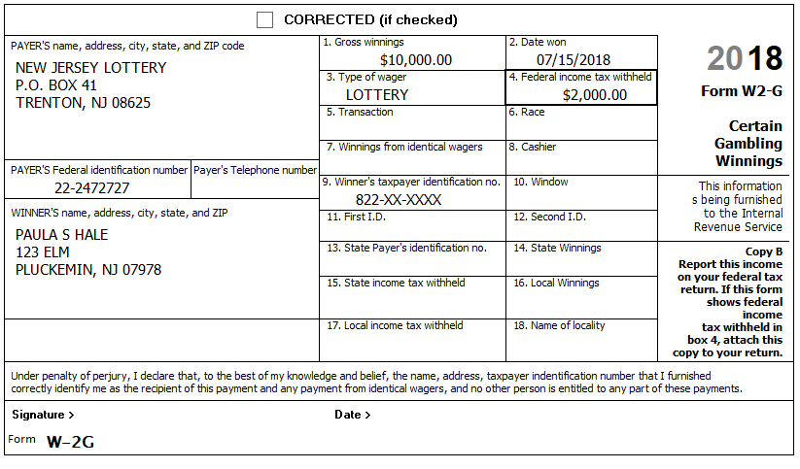
Paula had losses of $8,000 on slots and $4,000 on lottery tickets. (with documentation)
Reference: 4012 D-49
Hint: Because there is only one W-2G, it is safe to include losses on the W-2G screen.
NJ: Record on NJ Checklist (NJ Line 24 – Gambling Winnings)
Federal AGI: 66,003 Federal Refund: 3,245 NJ Refund: 700
Q: Why did Federal AGI go up by more than the amount of the lottery winnings?
Step 13 New Jersey Estimated payments
They made the following NJ estimated payments:
Tax Year | TY2017 | TY2018 | TY2018 | TY2018 | TY2018
Date | 01-03-2018 | 04-14-2018 | 06-15-2018 | 09-11-2018 | 12-28-2018
Amount | $50.00 | $60.00 | $60.00 | $60.00 | $70.00

Step 13a Schedule A – Taxes You Paid
Federal AGI: 66,003 Federal Refund: 3,245 NJ Refund: 700
Step 13b Payments – State Estimated Payments
Federal AGI: 66,003 Federal Refund: 3,245 NJ Refund: 950

Step 14 Notes – Itemized Deductions
Check: Before beginning this step, Use Compare Deductions to check that Itemized Deductions = 11,245 (equals: 1,245 (Line 7) + 10,000 (Line 16))
Hint: Some items in the following sub-Steps may not be deductible or may have already been entered – be alert…
Step 14a Notes – Deductions – Medical and Dental
Medicare – Part B $1,385
Medicare – Part D $810
Insurance paid by Office of Personnel Management $2,300
Insurance policy from HealthCare.gov $6,360
Doctor co-pays and deductibles $300
Long Term Care (LTC) insurance (Paula) $1,800
Reference: 4012 F-5 to F-6
Hint: The appropriate deduction amount for Marketplace (HealthCare.gov) policies can only be calculated after form 8962 has been completed – do NOT enter now – we will do this later.
Federal AGI: 66,003 Federal Refund: 3,245 NJ Refund: 950
Check: After this step, Itemized Deductions = 12,650
Step 14b Notes – Deductions – Taxes You Paid
Net Real estate tax (Principal residence) (Gross=7,385) $7,135
Real estate tax (Condo in Las Vegas) $1,865
Reference: 4012 F-6
BP: You must click “Add Sales Tax Worksheet” and enter State, Zip, and Number of days (but not percents) even if you do not have any extra sales tax on cars, etc.
The Hale’s home in NJ is a single-family house; ownership is not shared.
According to the postcard from the tax office: – Block=50001, Lot-00002, Qualifier is blank.
NJ: Record appropriate Real estate tax and BLQ info on NJ Checklist (Property Tax)
Federal AGI: 66,003 Federal Refund: 3,245 NJ Refund: 950
Check: After this step, Itemized Deductions = 21,405
Q: Why did Itemized Deductions only go up by 8,755?
Step 14c Notes – Deductions – Mortgage Interest
The Hales received a Form 1098 from Acme Mortgage related to the mortgage on their Principal residence.
Interest $2,135
Points $565
PMI $300
The Hales received a second Form 1098 from Acme Bank related to their Home Equity Line of Credit on their Las Vegas condo. The principal amount of $11,000 was all used for improvements.
Interest $777
Reference: 4012 F-9
Note: As of 12-09-2018 TSO allows you to enter PMI; however, it is not included in calculations. PMI lapsed at the end of TY2017 and has not been extended (yet).
Federal AGI: 66,003 Federal Refund: 3,245 NJ Refund: 950
Check: After this step, Itemized Deductions = 24,882
Step 14d Notes – Deductions – Gifts to Charity
Church cash donations with church generated listing $520
Contribution to the Pluckemin Archaelogical Project with canceled check $80
Cash donations to Santa ringing bell outside grocery store (no records) $22
Donation to a political party $50
Reference: 4012 F-10
Tool: IRS Exempt Organization Search (link on Preparer page)
Hint: Use the Exempt Organization Search tool to check if donations to the Pluckemin Archaelogical Project are tax-exempt. (Just enter Pluckemin in the Name search field.) [If you click on the charity name to get details, you will see that although it is a 501(c)(3), it is on the Auto-Revocation List. For purposes of the problem, you may assume that the organization has been reinstated.]
Hint: If you use the Override option for Cash, then all you need to enter is the total (no names, dates, etc.) – Just be sure to document in the TP’s paper file how you arrived at the total.
Federal AGI: 66,003 Federal Refund: 3,245 NJ Refund: 950
Check: After this step, Itemized Deductions = 25,482

Step 15 Notes – Homestead Benefit Recovery
The Hales received a total Homestead Benefit of $400 applied (in two parts) to their quarterly property tax bills. The amounts are shown on their printed tax bills from the township. (If they didn’t have evidence of the amount, you could look up the amount online)
The Homestead Benefit received in TY2018 is for TY2015. You do not have a copy of their TY2015 return, but they assure you that their tax situation has been pretty consistent since Stephen retired, i.e. Their Itemized deductions were several thousand dollars greater than the Standard Deduction and their taxable income was similar to this year.
Reference: New Jersey Special Handling
Tool: NJ Inquiry for Homestead Benefit (link on Preparer page)
NJ: Recovery amount should be included on the NJ Checklist (Adjustments to Line 26)
Federal AGI: 66,403 Federal Refund: 3,197 NJ Refund: 950
Check: After this step, Itemized Deductions = 25,422 – why did it go down by 30?
Step 16 Credit for the Elderly or the Disabled
TaxSlayer does not automatically check eligibility for the Credit for the Elderly or the Disabled (Schedule R); the preparer must use the chart on page G-14 of Pub. 4012 to manually determine potential eligibility. If potentially eligible, then the preparer must provide the information necessary to calculate official eligibility and the amount of the credit, if any.
Reference: 4012 G-17 to G-19
Federal AGI: 66,403 Federal Refund: 3,197 NJ Refund: 950
Q: Is TP eligible for this Credit? If not, why not?

Step 17 ACA Health Insurance
Stephen had Medicare all year.
Paula had a Marketplace (HealthCare.gov) policy all year.
Wanda had insurance from her former employer through December 5th of the prior year. She had COBRA coverage from February 25th to June 30th of the current year. She had Medicare from September 1st to December 31st of the current year.
Wanda did not have a federal filing requirement.
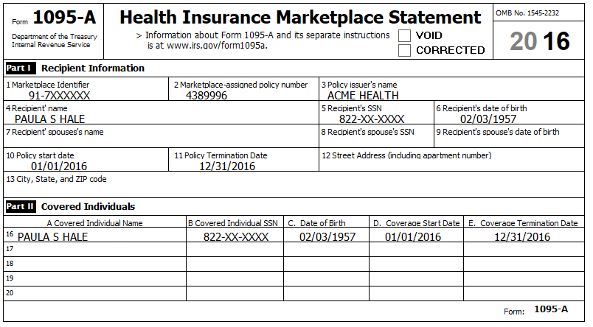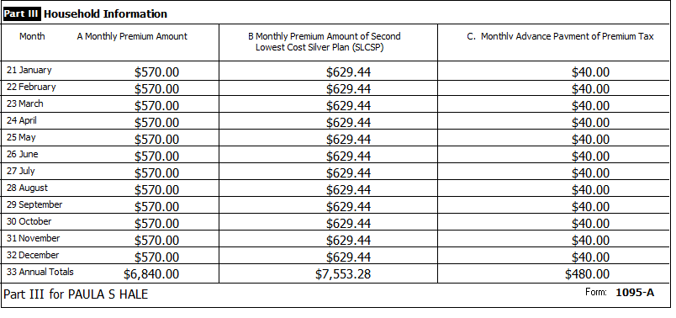
Reference: 4012 Tab H

Step 17a ACA Health Insurance – Health Insurance Section
Hint: Your local ACA expert says that the only exemption Wanda might qualify for during the periods when she did not have insurance is the Short Coverage Gap (Code B).
Federal AGI: 66,403 Federal Refund: 3,444 NJ Refund: 950
Step 17b ACA Health Insurance – Add Sch A amount
Hint: To calculate the correct amount for Sch. A, you need to look at a couple of lines on the 1040 after completing the Health Insurance section in TSO. Use the following procedure:
- Calculate the “TY Net Premium” by subtracting the 1095-A, Column C total from the Column A total. (e.g. 6,840 – 480 = 6,360)
- Calculate the “Sch A Deduction Amount”:
  - If Sch 2, Line 46 (Excess advance premium tax credit repayment) has a value, add it to the “TY Net Premium”
  - If Sch 5, Line 70 (Net premium tax credit) has a value, subtract it from the “TY Net Premium”. (e.g. 6,360 – 422 = 5,938)
- Enter the “Sch A Deduction Amount” on the Medical Deductions screen in TSO.
BP: Be sure to document the calculation of the amount you end up entering into TSO for your Quality Reviewer and for the TP records.
Federal AGI: 66,403 Federal Refund: 4,020 NJ Refund: 950
Check: After this step, Itemized Deductions = 31,390

Corrections if you did problem before NJ Availability
There have been some changes to the problem and to TSO that may need to be fixed for your return to be in sync with a return entered from scratch.
Your Refund Monitor numbers before adding the NJ return should be:
Federal AGI: 66,403 Federal Refund: 4,014 NJ Refund: N/A
Other things to check:
Check: Fed 1040, line 2a=769; 2b=974; 3a=226; 3b=706
Check: Itemized Deductions = 31,360
Step X1a Add NJ Return
Go to State Section and click “ADD STATE RETURN(S)”
Select NJ, click “CONTINUE”
Select Resident, click “CONTINUE”
Federal AGI: 66,403 Federal Refund: 4,014 NJ Refund: 950
Step X1b NJ Property Tax Credit or Deduction
Click “NO”. (The correct answer is “YES”, but we will handle this later as part of entering info from the NJ Checklist)
Federal AGI: 66,403 Federal Refund: 4,014 NJ Refund: 950
Step X1c Taxpayer NJ Health Insurance & Spouse NJ Health Insurance
Click “YES” for both
Federal AGI: 66,403 Federal Refund: 4,014 NJ Refund: 950
Step X1d Check NJ Initial NJ Return
You should get the main NJ Return menu. You might want to double check some numbers on the initial NJ return:
Check: NJ-1040, line 16a=468; 16b=932; 16=706
Check: NJ-1040, line 19=11,961 (Wrong due to a bug in TSO, the correct value is 10,402)
Federal AGI: 66,403 Federal Refund: 4,014 NJ Refund: 950
Step X2 Sch K-1 line 5 bug
NOTE: As of 01-04-2019 there is a bug in TSO where it is not including amounts from K-1 box 5 (Interest Income) in NJ-1040, line 16a (Taxable Interest). Workaround: Do not enter box 5 amount on K-1 screen; enter box 5 amount as separate 1099-INT.
Remove the $343 from your K-1 screen box 5.
Add a new 1099-INT with the $343 in box 1.
Federal AGI: 66,403 Federal Refund: 4,014 NJ Refund: 950
Check: Fed 1040, line 2a=769; 2b=974; 3a=226; 3b=706
Check: NJ-1040, line 16a=811; 16b=932; 16=706
Step X3 New LTC limit
TSO recently updated the LTC limits from TY2017 to TY2018 values.
Change Paula’s LTC deduction amount to 1,560.
Federal AGI: 66,403 Federal Refund: 4,020 NJ Refund: 950
Check: Itemized Deductions = 31,390

State Section (New Jersey)
You have collected information during several Federal Steps on your NJ Checklist – It is now time to enter that information into TSO
Note: As of 01-06-2019, you must go to main NJ menu and click “EXIT NEW JERSEY RETURN” before TSO will re-calculate NJ Refund amount.
Step 18a NJ Checklist – Basic Information
Enter New Jersey State Return – Basic Information
Remember: Paula is blind, but NOT disabled
Remember: Steve is a Vet, but does not qualify for NJ Veteran Exemption
Federal AGI: 66,403 Federal Refund: 4,020 NJ Refund: 950
Check: NJ-1040, line 28a=41,799
Step 18b NJ Checklist – Income Subject to Tax
Enter New Jersey State Return – Income Subject to Tax
Federal AGI: 66,403 Federal Refund: 4,020 NJ Refund: 950
Check: NJ-1040, line 20a=42,799; 20b=619; 26=0
Step 18c NJ Checklist – Subtractions from Income
Enter New Jersey State Return – Subtractions from Income
Hint: Nothing to do here.
Federal AGI: 66,403 Federal Refund: 4,020 NJ Refund: 950
Step 18d NJ Checklist – Credits
Enter New Jersey State Return – Credits
Hint: Answer “Yes” to: “Are you eligible and file for a homestead benefit application to receive the property tax credit with the homestead benefit?
Federal AGI: 66,403 Federal Refund: 4,020 NJ Refund: 950
Check: NJ-1040, line 38a=7,385; 54=0

Step 18e NJ Checklist – Tax
Enter New Jersey State Return – Tax
Stephen and Paula discovered last year that they could buy things online and not pay NJ sales taxes so they did some Christmas shopping and purchased various other items online. When the NJ Use Tax rules were explained to them, they decided they better follow the NJ guidelines for reporting Use Tax on their NJ return because they had no easy way to calculate an exact total of purchases. None of the items cost more than $1,000.
Reference: NJ 1040 Instructions or link to Use Tax table on Preparer page
Hint: The amount on NJ-1040, Line 29 (New Jersey Gross Income) is $0 (Ordinarily, you would need to generate the return PDF to find this number). Using last year’s calculator, you get a Use Tax value of $14
Federal AGI: 66,403 Federal Refund: 4,020 NJ Refund: 936
Step 18f NJ Checklist – Payments
Enter New Jersey State Return – Payments
Hint: Nothing to do here.
Federal AGI: 66,403 Federal Refund: 4,020 NJ Refund: 936
Step 18g NJ Checklist – Miscellaneous Forms
Enter New Jersey State Return – Miscellaneous Forms
The Hales ask you to create next year’s NJ-1040-ES (Estimated Payment) vouchers for $20 per quarter.
Federal AGI: 66,403 Federal Refund: 4,020 NJ Refund: 936

e-File
Collect any final information necessary…
You will get a “State Validation Errors” message about NJ 1065 K-1 Begin Date is blank – you can ignore this message for practice returns
Step 18a E-File – Return Type
The Hales have a Federal refund which they want to Direct Deposit (per their Intake Sheet)
Hint: Federal Return Type = “E-file: Direct Deposit”
Step 18b E-File – Tax Preparation and E-File Information
EMail, if given, is on page 3 of the Intake Sheet
Step 18c E-File – State Return(s)
Hint: State E-file options not included (unless NJ K1 info provided)
Hint: State Return Type = “Paper Return with Direct Deposit”
Step 18d E-File – Taxpayer Bank Account Information
The Hales show you a check from the account at Acme Bank where they want their Federal and NJ refunds to be deposited: RTN#=081904808, Acct#=986532
Step 18e E-File – Third Party Designee Info
Hint: Do NOT fill in anything here.
Step 15f E-File – Consent to Disclose Tax Return Information …
The Hales DENY consent
Step 18g E-File – Questions
“Was the taxpayer physically present during the entire return preparation and quality review process?” – answer Yes
Step 18h E-File – State ID (Optional)
Ignore this section
Hint: Click Save when done
Step 18i E-File – Submission
BP: Do NOT check “Is Complete” or any other boxes on this screen at this point

